Design pattern
- MVC: model (data), view (chart etc.) controller (interaction)
- Abstract factory: create family of similar objects. Ex. All planner objects
- Adapter: make one class to be used as other class. Ex. Religious conversion
- Bridge: decouple abstraction from implementation. Ex. OS related implementation separates
- Builder: build complex objects. Ex. Pizza builder
- Chain of responsibility: Do and pass. Ex. Help page for different section.
- Command: encapsulate request as object. Ex. All menu items in editor
- Composite: treat single and aggregate as same. Ex. Graphics object
- Decorator: add additional responsibility to object. Ex. Accessories in car
- Façade: unified interface. Ex. home automation, compiler
- Factory: create object
- Flyweight: share object. Ex. Alphabet in editor
- Interpreter: language, grammar
- Iterator: c++ iterator
- Mediator: interaction between object in one class.
- Memento: save state for undo
- Observer: notify on change
- Prototype: create heavy object by cloning prototype
- Proxy: avoid object till needed. Remote proxy etc
- Singleton: one oject
- State: alter behaviour on state, state have new class. TCP state
- Strategy: algorithm family
- Template: common things in parent class
- Visitor: operation on objects, spell check
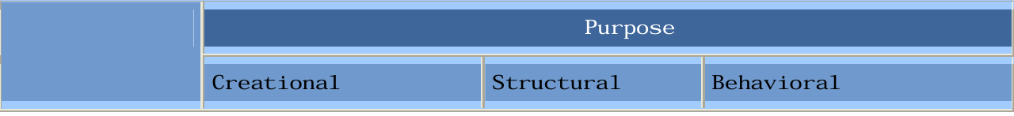
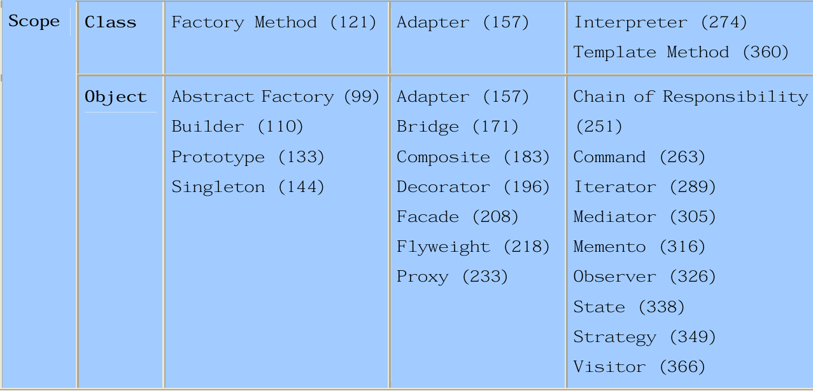

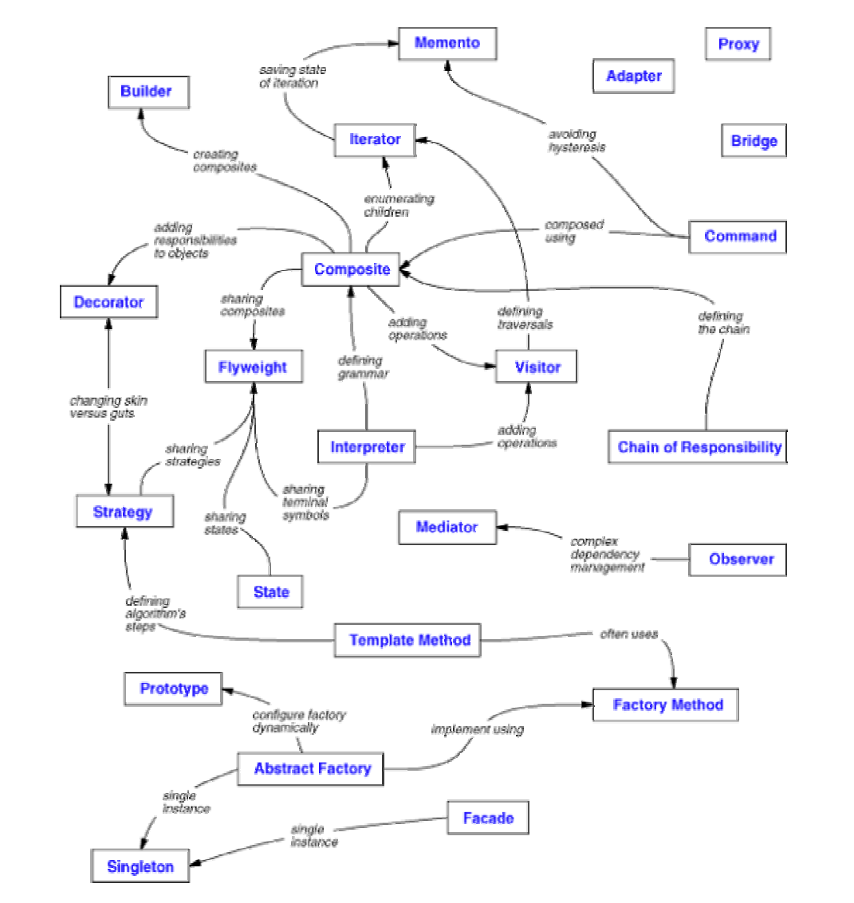

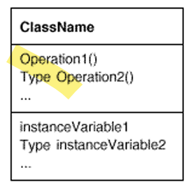
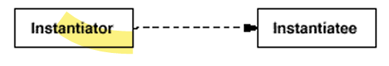
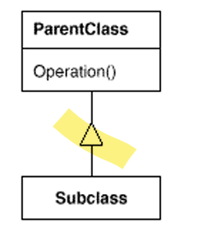
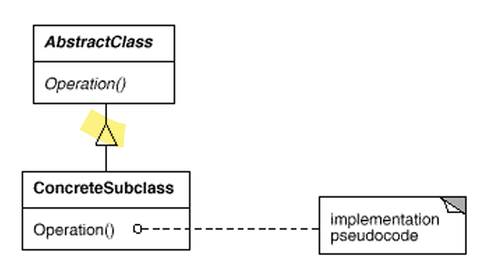
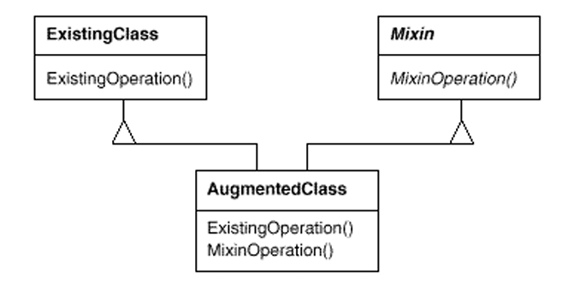
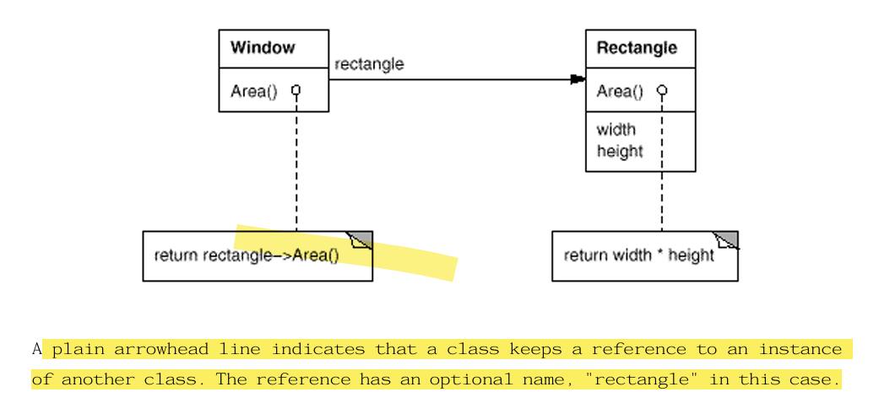
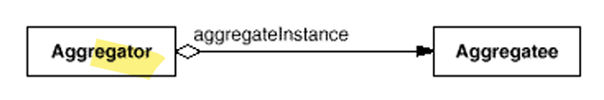

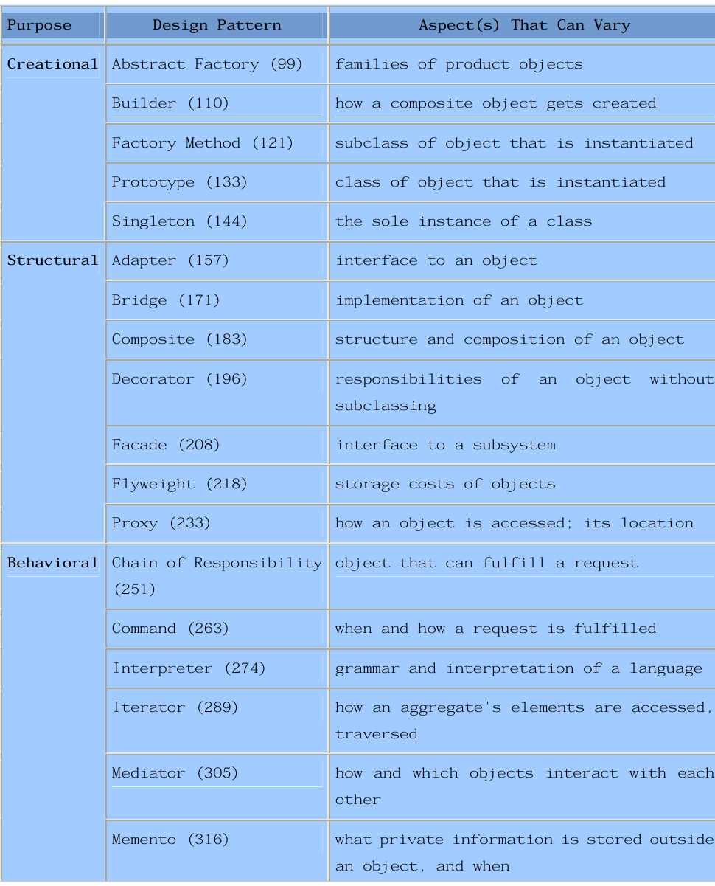
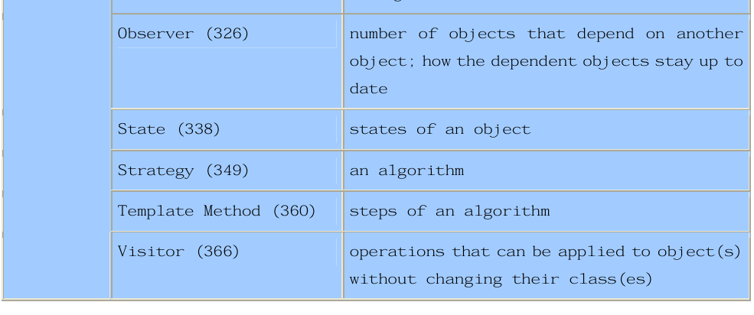

Creational

Abstract factory
- Create family of related objects.
- 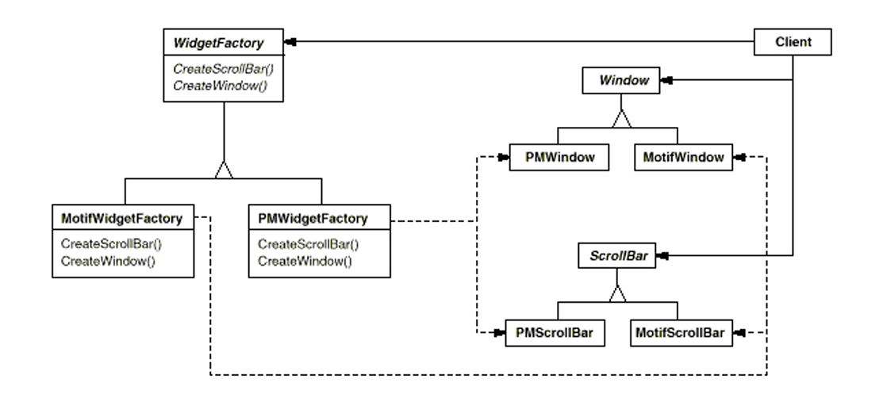
- Example: as above create a family of widget, create all planner related objects

Builder
- Separate construction of complex objects
- 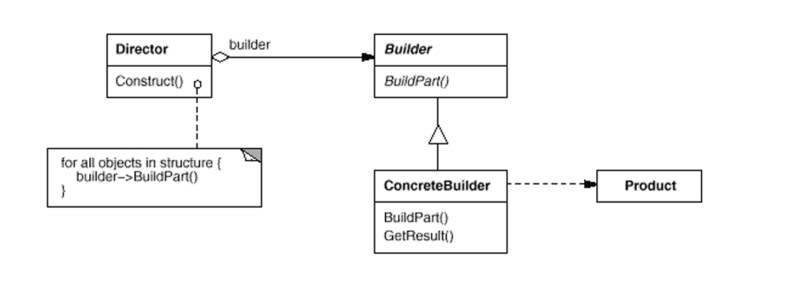
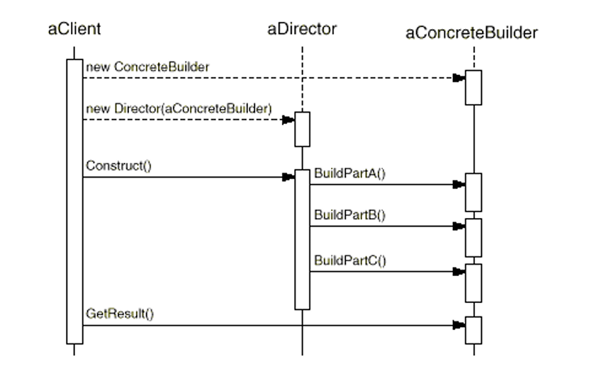
- Example: pizza builders build pizza by making base then cheese then sauce etc.
- Like abstract factory. Builders build complex objects and abstract factories create family of objects.

Factory
- Interface to create objects.
- Ex: 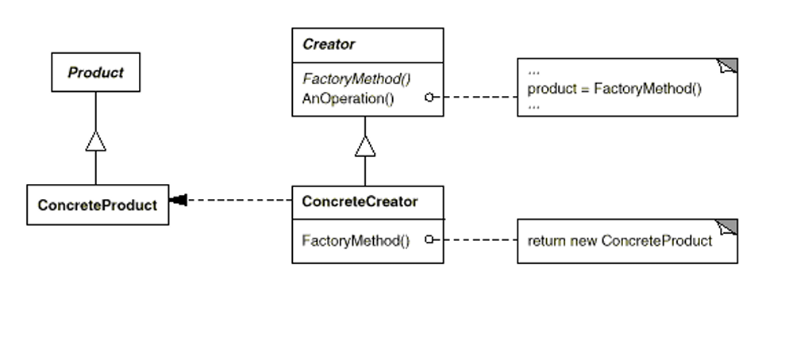
- Ex. Create classes to process different kinds of doc based on doc type
- Related: abstract factory, prototype

Prototype
- Create objects from prototype
- 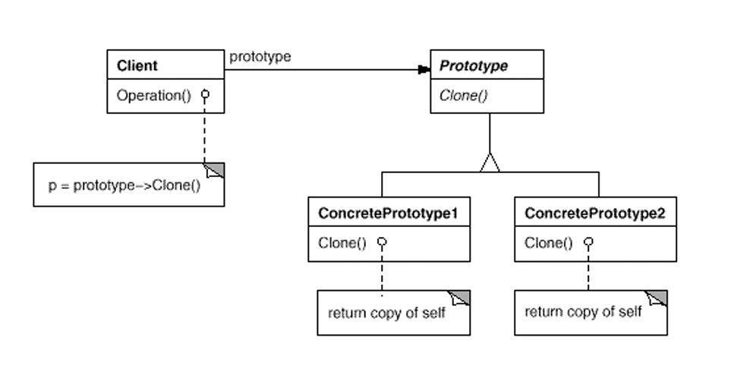
- Ex. For complex and multiuse objects keep the prototype and clone and create new objects when needed

Singleton
- Class have only one instance

Structural

Adapter
- Convert interface of one class to other.
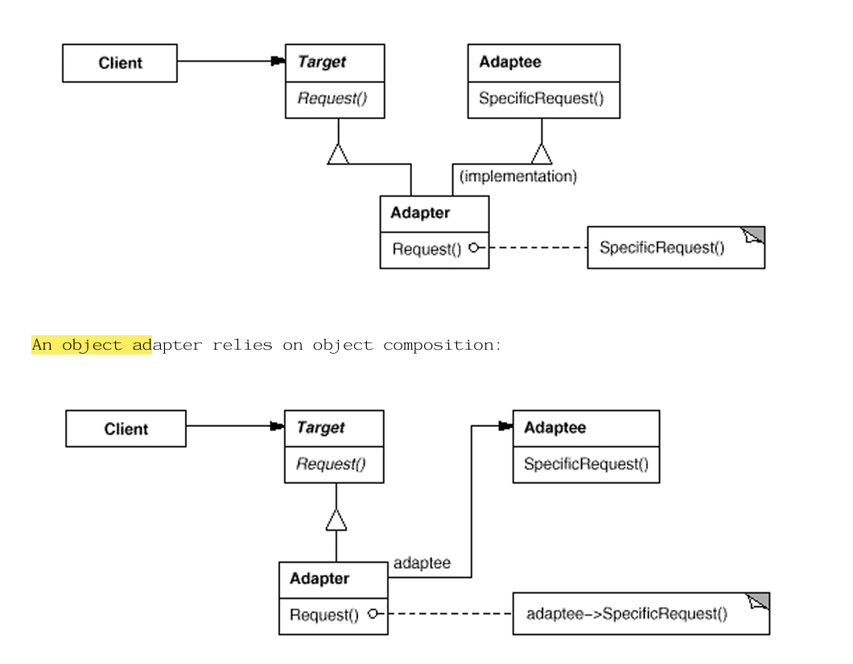
- Ex: muslim->hindu, dog->cat

Bridge
- Separate abstraction from implementation
- 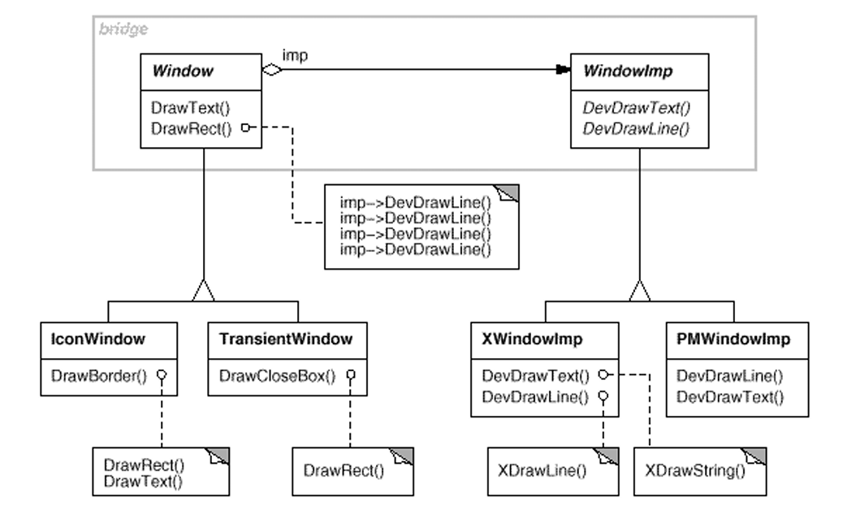
- Ex. To have platform dependent implementation in imp
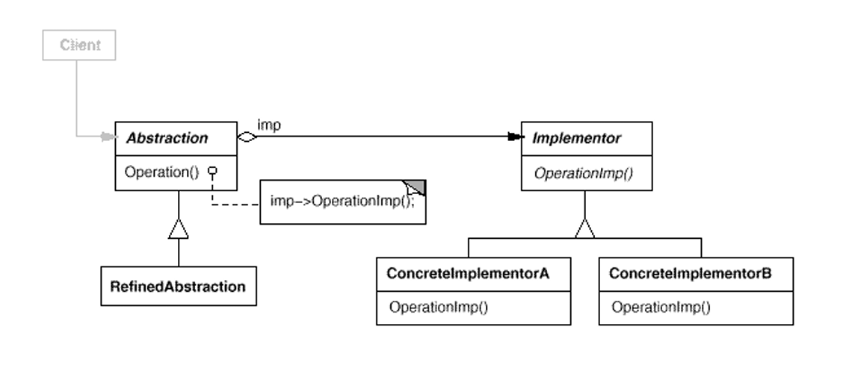
- Use factory, abstract factory to instantiate imp object

Composite
- Treat individual and composite same
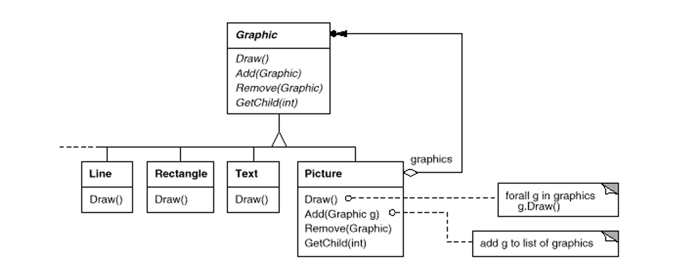
- Ex : as above , picture can have multiple graphics
- 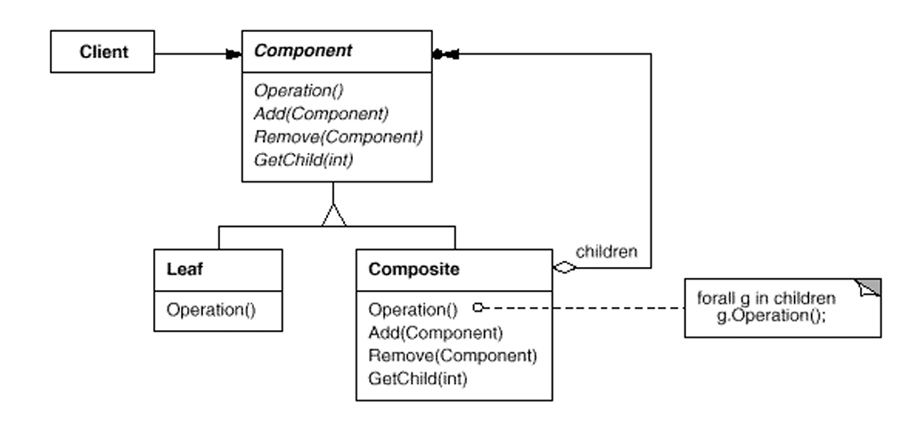

Decorator
- Add additional responsibility to object dynamically
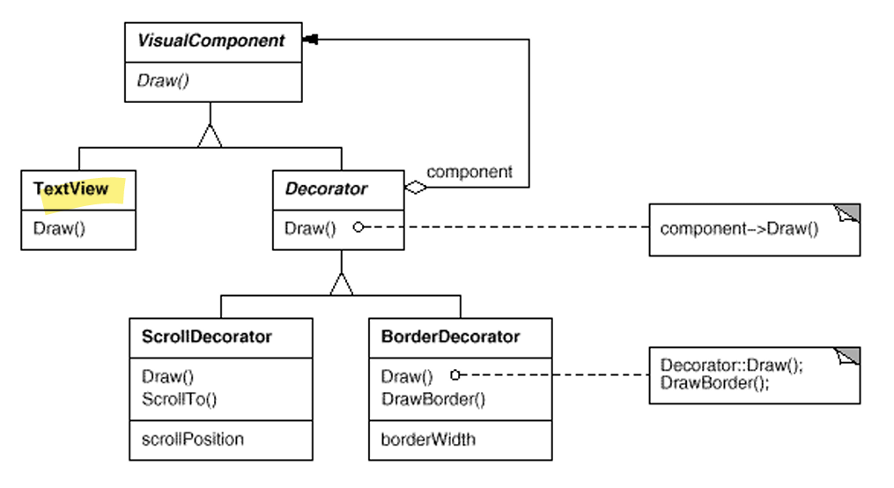
- Ex. Add accessories to car. Add scroll, border to text
- Change skin (decorator) change gut (strategy)

Façade
- High level interface to hide low level detail
- Ex. Compiler (hide parser, etc)
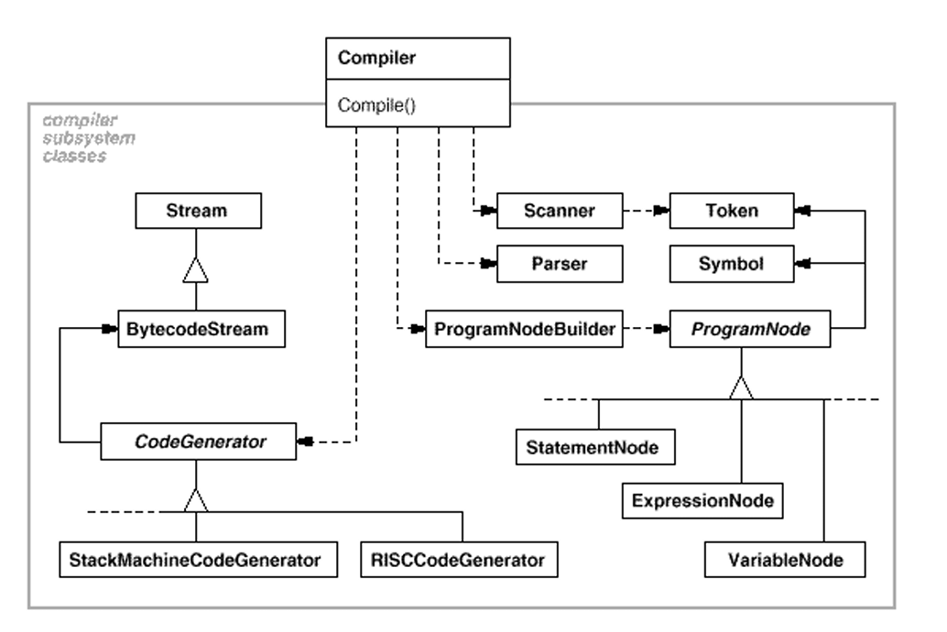

Flyweight
- Use sharing to support large number of fine grained object
- Keep intrinsic property in object , pass extrinsic property from outside(keep a map etc)
- Ex. All ASSCI chars can be shared , the font and style can be passed
- Use factory to get object , so it create once and reuse same
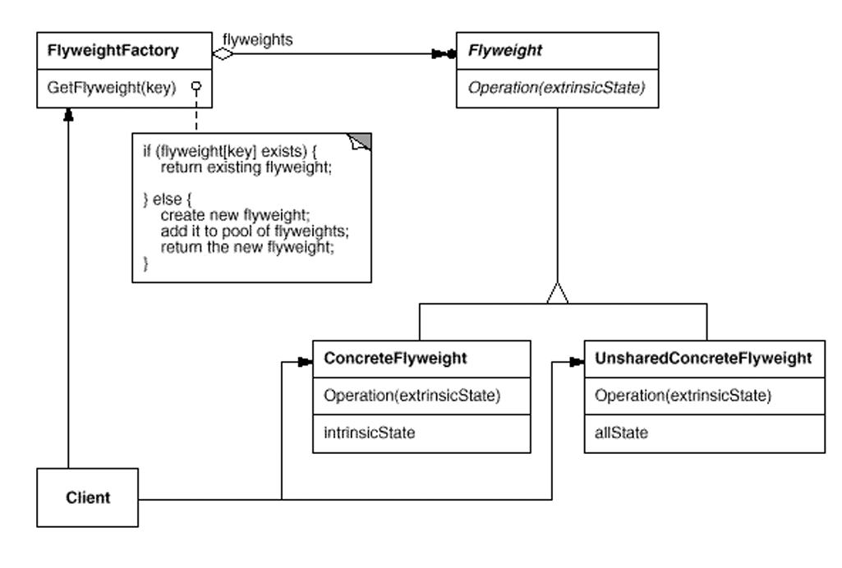

Proxy
- Placeholder till its needed
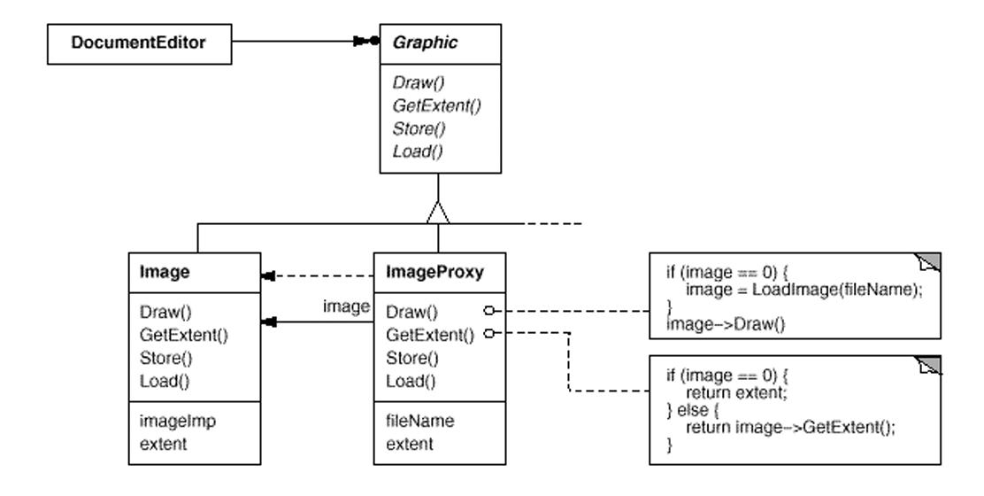
- Ex. Delay loading image till needed
- Ex. Remote proxy, virtual proxy, protection proxy

Structural pattern
- All use delegate and object composition.

Behavioral pattern

Chain of Responsibility
- Avoid coupling sender and receiver
- Ex. Show help for different gui items (if help for selected button is there show, else show that section help, else that gui help, else overall help
- 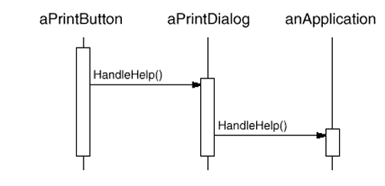
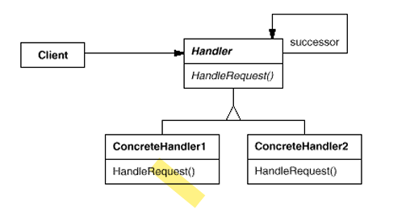

Command
- Encapsulate request as object
- Ex. Gui button operation, callbacks
- 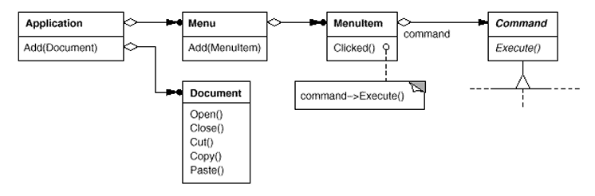
- 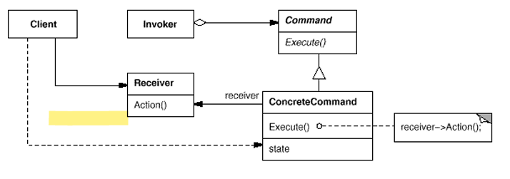

Interpreter
- Language and grammar
- 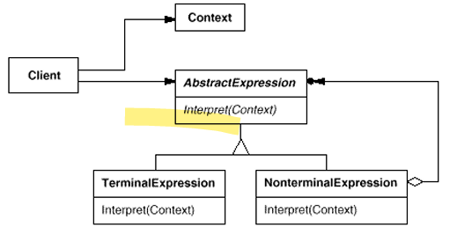
- Ex compilers

Iterator
- Iterate over items , c++ iterators
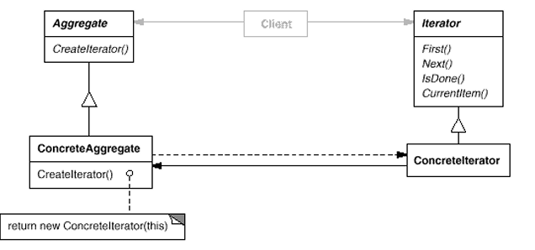

Mediator
- encapsulate how a set object interacts
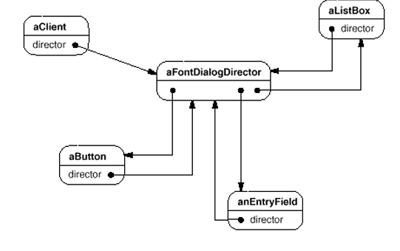
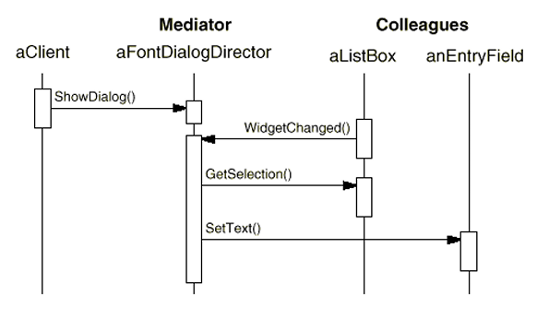
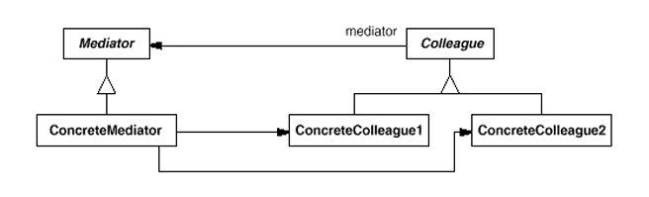

Memento
- for undo

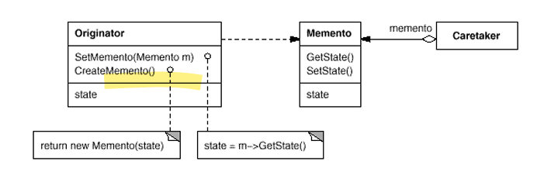

Observer
- gets notified on state change and take care of rest of operation. One-to-many dependency
- register observer, notify
- Ex. When data change all representations like bar graph table view etc. changes
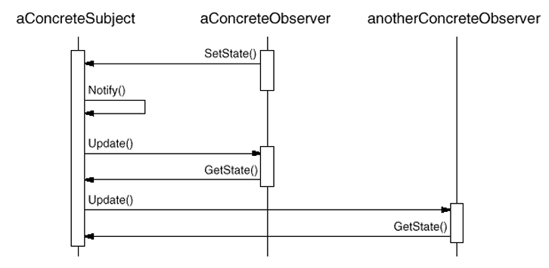
- Chang manager
- Pull/push model
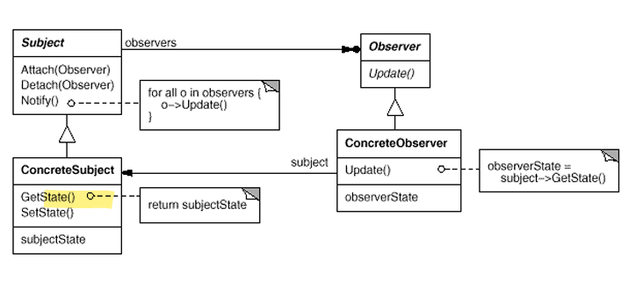

State
- Each TCP state behaves differently.
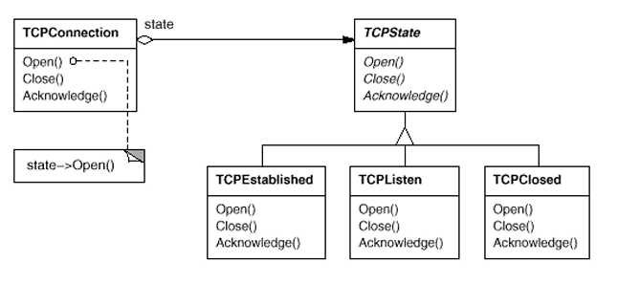
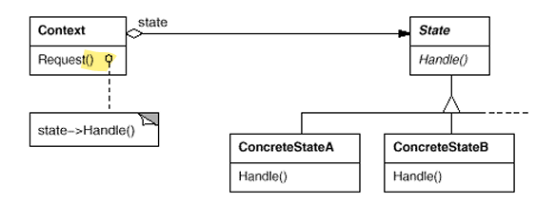

Strategy
- Family of algorithms, factory to init,
- Ex. Failover conflict resolution
- 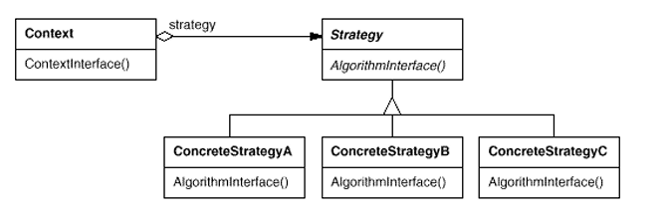

Template
- Parent have the outline, derived class just define specific behavior
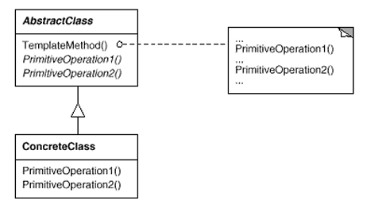

Visitor
- Operation performed on object. Define new operation without changing the class
- 
 